**Ideation Phase**

**Define the Problem Statements**

|  |  |
| --- | --- |
| Date | 31 January 2025 |
| Team ID | LTVIP2025TMID59890 |
| Project Name | Pattern Sense: Classifying Fabric Patterns using Deep Learning |
| Maximum Marks | 2 Marks |

**Customer Problem Statement Template:**

In the textile and fashion industries, identifying and categorizing fabric patterns (e.g., floral, striped, polka dot, geometric) is essential for inventory management, design cataloguing, quality control, and customer recommendation systems. Traditionally, this task relies on manual inspection, which is time-consuming, subjective, and prone to inconsistency.

With the growth of digital fashion platforms and large-scale textile production, there is a pressing need for an automated, scalable, and accurate method to classify fabric patterns from images.

Reference: <https://miro.com/templates/customer-problem-statement/>

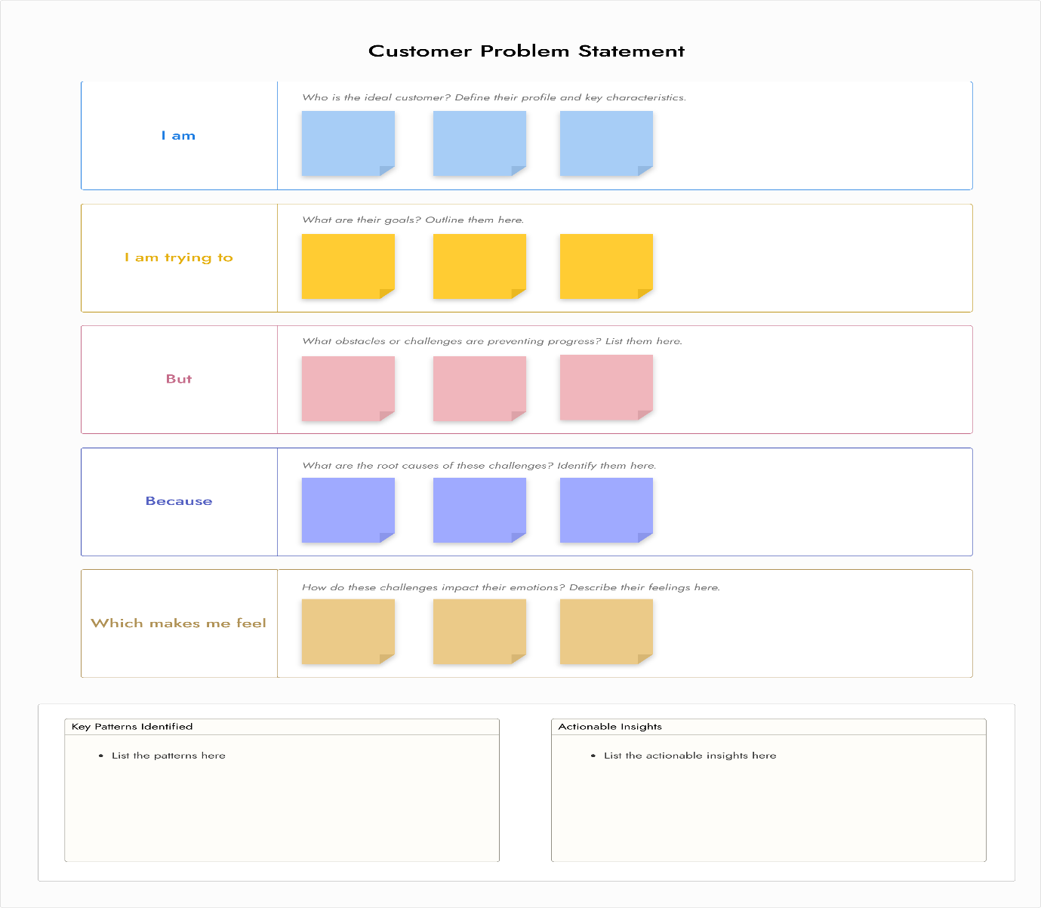

|  |  |  |  |  |  |
| --- | --- | --- | --- | --- | --- |
| **Problem Statement (PS)** | **I am (Customer)** | **I’m trying to** | **But** | **Because** | **Which makes me feel** |
| PS-1 | food processing plant head | make my workers manually sort to separate the rotten ones from the fresh produce. | this process is time-consuming and prone to human error. | the whole process is in manual operations | like frustrated |
| PS-2 | Supermarket manager | maintain customer satisfaction with product freshness | it is difficult to sort manually | the freshness of these products is crucial | like frustrated to sort |